How to Enroll a Student in Your Class:
- Login to Converge (both the teacher and student will need to login)
  - http://Southwesternhigh.net Your username is your email address and your password was originally set at Pulaski (many of you changed your password at the training). If you cannot remember your password, you can use the Forgot your password? link and get it reset. Recommended browser for this site is FireFox.
  - Once you login, you should be looking at your Dashboard. It will look something like the picture below. If your screen looks different, just click the Pulaski icon in the top left corner.
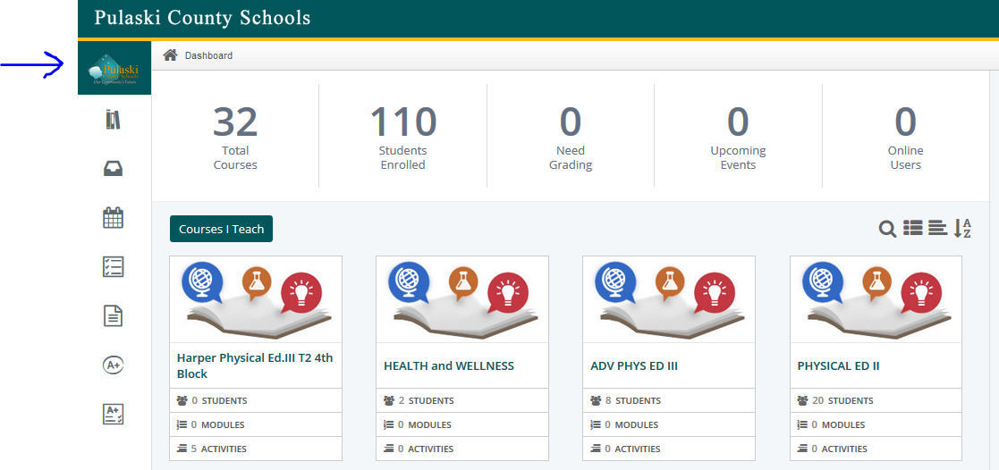
- Click on the class you wish to enroll students in. Look for the Course Access Code and have the student use that to access your class. The student will need to be logged in to Converge as well. You may need to expand the menu to make the access code show up.
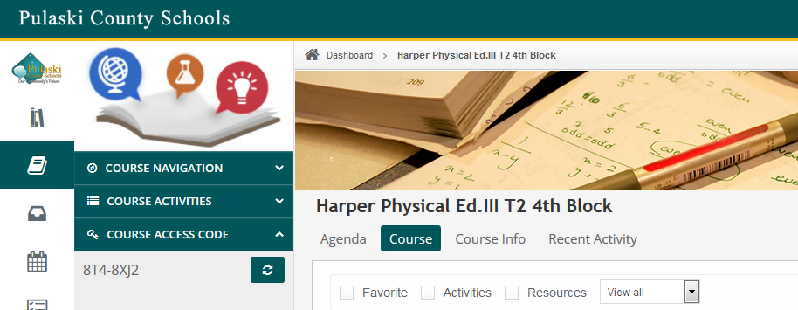
- Check to ensure that the student shows up in that class by clicking the courseSettings gear (in the top right)Enrollments

